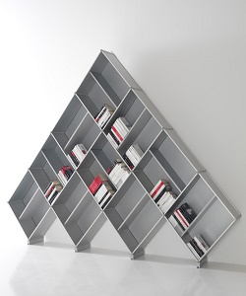

Bookcase

$49.018

Availability: In stock

**Description:**

The real modular extruded aluminum bookcase with a unique and exclusive pyramid shape, a special way to personalize your space. It’s a system that can be used everywhere: in office to contain files of filling cabinets, in living room as a large bookcase, in kitchen as a pantry, hanging in bathroom for towels and perfumes, in a book store of a winebar.This furniture is usable for every need.